Hybrid Vector Search and Knowledge Graph Retrieval for Clinical Question Answering and Medical Visual Diagnosis
Harshit Kapur, Sabah Mohammed and Jinan Fiaidhi
Department of Computer Science, Lakehead University
Thunder Bay, Ontario, Canada
Abstract
Retrieval-Augmented Generation (RAG) and knowledge-graph augmentation are widely proposed to address the frozen, and potentially outdated, parametric knowledge of large language models (LLMs) in clinical question answering. This paper investigates whether such augmentation improves clinical reasoning over an unaugmented baseline, evaluating a progression of four architectures — a no-retrieval baseline, flat-vector RAG, static GraphRAG, and a hybrid system combining BM25 keyword search, dense vector retrieval, and structured knowledge graph traversal — across both textual and visual medical question answering benchmarks. On the complete 1,273-question MedQA-USMLE benchmark, where Claude Opus 5 achieves a strong parametric baseline of 96.0%, no retrieval- or graph-augmented configuration produces a meaningful improvement: flat-vector RAG reaches 96.5% and hybrid GraphRAG 96.2%, differences attributable to noise rather than genuine augmentation benefit. Scaling the knowledge graph from task-specific document extraction to PrimeKG [7], a Harvard precision medicine knowledge graph integrating 20 biomedical resources across 17,080 diseases, filtered here to 12,752 clinical entities and 441,429 relationships — does not recover this deficit, indicating that the shortfall is not attributable to insufficient graph richness but to the redundancy of injected context when the base model already encodes the benchmark's knowledge. The picture changes substantially on medical visual question answering, where parametric knowledge is genuinely insufficient: on 1,010 yes/no questions from PathVQA, the hybrid system reaches 79.6% against a baseline of 68.0% — an 11.6 percentage point gain — demonstrating that hybrid knowledge-graph retrieval provides meaningful clinical grounding precisely where the model's parametric knowledge falls short. We report these results as a statistically grounded account of when retrieval and graph augmentation help — and when they do not — in clinical AI, and outline directions, including multimodal knowledge graph construction and trustworthiness-oriented evaluation metrics, for a more rigorous future test of the underlying hypotheses.
Index Terms—Hybrid GraphRAG, Retrieval-Augmented Generation, Knowledge Graphs, Clinical Question Answering, Visual Question Answering, Large Language Models, MedQA, PathVQA, PrimeKG, Medical AI
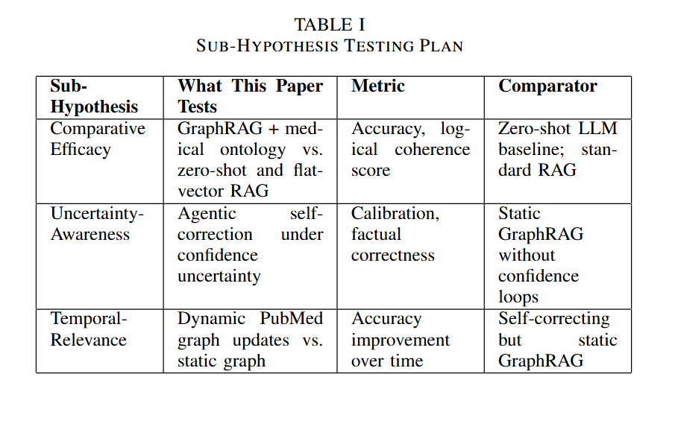
I. INTRODUCTION
Large Language Models have demonstrated impressive linguistic and reasoning capabilities across a wide range of benchmarks, yet they exhibit a fundamental structural limitation in high-stakes clinical domains: their knowledge is encoded implicitly in model weights and frozen at the point of pre-training [1]. This renders LLMs unable to reflect the continuous evolution of medical literature — new drug approvals, revised dosing guidelines, emerging resistance patterns, and updated diagnostic criteria — that defines the operational reality of evidence-based medicine [2]. Operating as probabilistic sequence generators, LLMs prioritize linguistic fluency over factual veracity, and can produce hallucinations that are clinically plausible but factually dangerous when queried at the boundaries of their parametric knowledge. For clinical question answering, where the difference between the correct drug and a plausible alternative can be a matter of patient safety, this bottleneck is not a technical inconvenience — it is a fundamental barrier to deployment.
The central research problem this paper addresses is the insufficient precision of standard retrieval methods for clinical reasoning, and the conditions under which hybrid retrieval — combining structured knowledge graph traversal with vector-based evidence retrieval — genuinely improves over unaugmented and single-strategy baselines. To investigate this, we examine the following hypothesis: that augmenting LLMs with hybrid retrieval will yield clinical question-answering outputs that are simultaneously more factually grounded, more structurally precise in their reasoning chains, and more robust across both textual and visual clinical modalities than those produced by either unaugmented LLMs or single-strategy retrieval baselines.
The most widely adopted approach to addressing the LLM knowledge bottleneck, besides fine-tuning and prompt engineering, is Retrieval-Augmented Generation (RAG), in which semantically similar passages from an external, updatable corpus are retrieved at inference time and prepended to the LLM prompt [4]. RAG decouples knowledge currency from model weights, reducing hallucination in knowledge-intensive tasks and enabling the LLM to reason over evidence outside its training distribution without retraining. However, retrieval precision remains a persistent and systematic weakness of flat-vector RAG: a passage that scores highly on embedding similarity may be topically related to a clinical query while containing none of the specific causal reasoning required to answer it. In expert domains such as medicine, this retrieval noise is not a minor inconvenience — prior work has documented that standard RAG can perform worse than no retrieval at all when the retrieved context is misleading rather than informative [3]. Flat-vector RAG thus addresses the currency problem but introduces a new one: it cannot guarantee that what it retrieves is clinically relevant, only that it is semantically proximate.
Addressing the central research problem of this paper requires evaluating three constituent sub-hypotheses. First, the Comparative Efficacy Hypothesis posits that a hybrid retrieval framework integrating BM25 keyword search, dense vector retrieval, and structured knowledge graph traversal will yield statistically significant improvements in clinical accuracy over zero-shot baseline models and single-strategy retrieval baselines. Second, the Domain-Sensitivity Hypothesis posits that the benefit of retrieval augmentation is modulated by the sufficiency of the model's parametric knowledge — manifesting as ceiling effects on benchmarks well-represented in training data, and as meaningful gains on tasks where parametric knowledge is genuinely insufficient. Third, the Multimodal Generalization Hypothesis posits that hybrid GraphRAG benefits demonstrated on textual clinical QA will generalize to medical visual question answering, where visual evidence and structured clinical knowledge must be jointly integrated to support accurate diagnosis.
A second research direction addresses retrieval noise directly by replacing unstructured passage retrieval with structured graph traversal. Knowledge Graph-augmented RAG (GraphRAG) represents clinical entities — diseases, symptoms, medications, procedures, and mechanisms — along with their typed relationships as explicit graph nodes and edges, enabling retrieval that is structurally relevant rather than merely semantically similar [6]. Each retrieved subgraph carries a relational specificity that a raw text chunk cannot match: not merely that metformin co-occurs with diabetes in a passage, but that metformin treats type 2 diabetes mellitus, is contraindicated in renal impairment, and is indicated as first-line therapy under specific clinical conditions. This structured precision motivates the hypothesis that a hybrid system combining graph traversal with keyword and vector retrieval will outperform flat-vector RAG in clinical settings.
To evaluate the Comparative Efficacy and Domain-Sensitivity Hypotheses, we compare four retrieval architectures — a no-retrieval parametric baseline, flat-vector RAG, static GraphRAG, and a hybrid system combining BM25 keyword search, dense vector retrieval, and knowledge graph traversal — on the complete 1,273-question MedQA-USMLE benchmark using Claude Opus 5. We further construct three progressively richer knowledge graphs: a task-specific graph extracted from MedQA training data (1,330 entities), a biomedical literature graph from PubMedQA abstracts (1,968 entities), and — PrimeKG [7], a Harvard precision medicine knowledge graph integrating 20 biomedical resources across 17,080 diseases, filtered here to 12,752 clinical entities and 441,429 relationships. — to assess whether graph richness modulates retrieval benefit independently of architecture.
To evaluate the Multimodal Generalization Hypothesis, we extend the same hybrid retrieval pipeline to medical visual question answering on PathVQA [8], a pathology benchmark of 1,010 yes/no questions, using Claude Haiku as the backbone model. Rather than assuming these augmentations improve performance, we evaluate each architecture directly and at full scale; the resulting findings, analyzed in Section V, provide an empirically grounded and, in several respects, illuminating account of when retrieval and graph augmentation help — and when they do not — in clinical AI, and outline directions for more trustworthy, evidence-grounded medical question answering systems.
II. RELATED RESEARCH WORK
The challenge of equipping LLMs with precise, current, and verifiable clinical knowledge has generated a rich landscape of retrieval and reasoning strategies by various scholars (see figure 1).

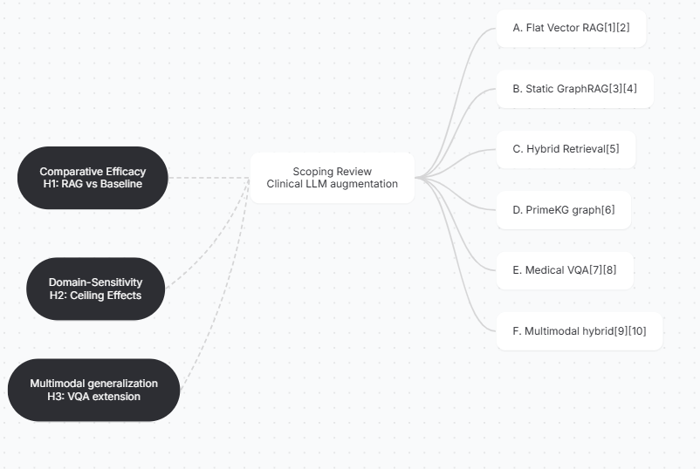

Fig.1 illustrates a mind map of our scoping review through the current literature relevant to the three sub-hypotheses introduced in the previous section.
The foundational RAG paradigm couples an LLM with a dense vector retriever that encodes external documents as embeddings and retrieves the top-k most similar passages at query time [4]. This framework was established as a general approach for knowledge-intensive NLP tasks, and subsequently extended by interleaving iterative retrieval with chain-of-thought reasoning [11]. In the biomedical domain, RAG has been adapted to clinical corpora including PubMed abstracts, electronic health records, and medical examination question banks. Wang et al. [5] conducted a systematic evaluation of RAG best practices, finding that hybrid retrieval combining BM25 sparse search with dense vector retrieval consistently outperforms either method alone across multiple benchmarks — a finding that directly motivates the hybrid architecture evaluated in this paper. However, the fundamental limitation of flat-vector retrieval remains precision: semantic similarity does not guarantee clinical relevance, and retrieved passages frequently contain extraneous context that degrades LLM reasoning performance [3].
B. Static GraphRAG and Knowledge Graph Reasoning
GraphRAG architectures, introduced by Edge et al. [6], address retrieval noise by organizing source documents into community-based knowledge graphs and enabling local and global search over entity-centric subgraphs. Ahmad et al. [12] benchmarked vector RAG, GraphRAG, and a hybrid combination on domain-specific specifications, finding that GraphRAG improved context relevance and hybrid GraphRAG improved factual correctness over flat-vector retrieval. In the medical domain, Wu et al. [13] proposed MedGraphRAG, constructing a three-tier knowledge graph linking patient documents to medical papers and the UMLS medical ontology, demonstrating consistent improvements over standard RAG across nine medical benchmarks. In this paper, we extend static GraphRAG evaluation to three progressively richer knowledge graphs — a task-specific MedQA graph (1,330 entities), a PubMedQA literature graph (1,968 entities), and PrimeKG [7], a Harvard precision medicine graph from which we extract a clinically filtered subgraph of 441,429 relationships — and show that domain alignment between the knowledge graph and evaluation task matters more than raw graph size. These results establish that graph structure improves retrieval precision, while also revealing that static graphs offer limited benefit when the backbone model's parametric knowledge already covers the benchmark domain.
C. Multi-Hop and Chain-of-Thought Reasoning
Many clinical questions require synthesizing evidence across multiple entities and relationships — standard single-hop retrieval fails such queries. GraphRAG architectures naturally support multi-hop reasoning by traversing entity neighborhoods and community subgraphs, enabling the model to connect, for example, a disease to its phenotypes, contraindicated medications, and associated genetic markers in a single retrieval pass [6]. StepChain GraphRAG [14] addresses complex multi-hop queries by decomposing questions into sub-questions and performing BFS-based graph traversal to assemble explicit evidence chains. The combination of structured graph retrieval and explicit multi-hop reasoning is particularly relevant to clinical QA, where a single question may require integrating findings from imaging, laboratory values, pharmacology, and clinical guidelines simultaneously. In this paper, we evaluate GraphRAG's multi-hop capability on textual clinical QA through PrimeKG [7] — a knowledge graph spanning ten biological scales, from which we extract a clinically filtered subgraph of 441,429 relationships — and, separately, on medical visual question answering through a task-specific knowledge graph constructed from the target domain.
D. Medical Visual Question Answering
Medical Visual Question Answering (VQA) extends clinical question answering to multimodal settings requiring joint reasoning over image content and structured clinical knowledge. Early work on VQA-RAD [15] demonstrated that radiology question answering benefits from both visual understanding and clinical terminology grounding, establishing a benchmark of 3,515 question-answer pairs across chest X-rays, brain MRI, and CT imaging. PathVQA [8] extended this to pathology, providing 32,799 question-answer pairs derived from 4,998 pathology images, spanning open-ended and binary yes/no questions across multiple organ systems and tissue types. Despite the clear clinical relevance of grounding visual answers in structured medical knowledge, the application of GraphRAG to medical VQA remains largely unexplored. Existing approaches rely predominantly on vision-language model fine-tuning or flat-vector retrieval over image captions, without leveraging the relational structure of clinical knowledge graphs. This paper presents the first systematic evaluation of hybrid GraphRAG augmentation for medical visual question answering, demonstrating consistent improvements over vision-only baselines — +11.6 percentage points on PathVQA — across pathology imaging using Claude Haiku as the backbone vision-language model.
E. Clinical Knowledge Graph Resources
The quality and domain alignment of the underlying knowledge graph is a critical determinant of GraphRAG performance in clinical settings. The Unified Medical Language System (UMLS) [16] provides a comprehensive medical ontology integrating over 60 biomedical vocabularies with typed semantic relationships between concepts serving as a foundational resource for clinical NLP. More recently, PrimeKG [7] — developed at Harvard — integrates 20 curated biomedical databases including DrugBank, DisGeNET, the Human Phenotype Ontology, and the Gene Ontology, encoding 129,375 nodes and 4,050,249 relationships across ten biological scales spanning drugs, diseases, genes, proteins, and phenotypes. PrimeKG's multi-scale relational structure makes it particularly well-suited for clinical GraphRAG, providing the kind of typed, provenance-tracked relationships — disease-phenotype associations, drug contraindications, gene-disease links — that flat document retrieval cannot represent. In this paper, we evaluate three knowledge graphs of increasing richness and domain scope, finding that domain alignment between the knowledge graph and the target task matters more than graph scale: PrimeKG's breadth does not overcome parametric saturation on textual clinical QA, while a smaller task-specific graph proves more effective on medical visual question answering.

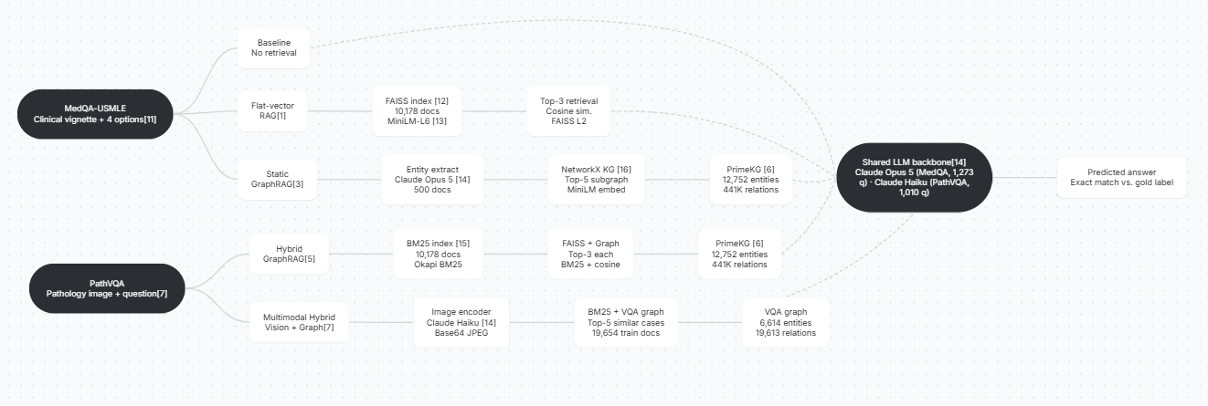
Fig. 2. Methodology overview of the four evaluated retrieval architectures and their extension to the multimodal setting. Text-based architectures use Claude Opus 5 (MedQA, 1,273 questions); the multimodal architecture uses Claude Haiku (PathVQA, 1,010 questions). Within each benchmark all systems share a common backbone and are evaluated on identical test sets, isolating retrieval strategy as the sole independent variable

The approaches surveyed above are not competing paradigms but a progressive sequence of partial solutions, each resolving one limitation while exposing the next. Flat-vector RAG addresses parametric staleness but introduces retrieval noise — semantically proximate passages that lack clinical precision. Static GraphRAG eliminates retrieval noise through structured traversal but remains limited by the richness and domain specificity of the underlying knowledge graph. Scaling the knowledge graph from task-specific extraction to comprehensive biomedical ontologies such as PrimeKG [7] partially addresses this limitation, but graph quality alone does not resolve the challenge of integrating heterogeneous evidence sources — keyword matches, semantic embeddings, and relational graph traversals — into a coherent clinical answer. Multi-hop chain-of-thought reasoning extends single-hop retrieval to complex multi-entity queries but depends critically on the quality and domain alignment of the knowledge graph it traverses. No single paradigm simultaneously satisfies all three properties that clinical question answering demands: retrieval precision, relational reasoning, and multimodal generalization. A hybrid architecture that combines BM25 keyword search, dense vector retrieval, and structured knowledge graph traversal is therefore the natural candidate for jointly satisfying all three sub-hypotheses raised in this paper — the Comparative Efficacy, Domain-Sensitivity, and Multimodal Generalization hypotheses — and constitutes the central empirical contribution of the work that follows.
III. PROPOSED RESEARCH METHODOLOGY
This section describes the four retrieval architectures evaluated in this paper (A–D), together with their extension to the multimodal setting (E), whose components and data flow are illustrated in Figure 2. All architectures are evaluated on identical test samples across two benchmarks — MedQA-USMLE [9] and PathVQA [8] — isolating retrieval strategy as the sole independent variable. Text-based architectures (A–D) use Claude Opus 5 [19] as the backbone model; the multimodal architecture (E) uses Claude Haiku [19] to accommodate vision inputs at reduced inference cost.
The first architecture (A) establishes a no-retrieval parametric baseline by prompting the LLM directly with the clinical question and answer options, without any external context. This baseline quantifies the frontier model's parametric knowledge on each benchmark.
The second architecture (B) introduces flat-vector RAG [4], encoding the full MedQA training corpus (10,178 documents) into a FAISS index [17] using the all-MiniLM-L6-v2 sentence transformer [18] and retrieving the top-3 most semantically similar passages at query time via cosine similarity.
The third architecture (C) replaces unstructured passage retrieval with a static typed knowledge graph constructed from 500 MedQA training documents via Claude Opus 5-driven entity and relation extraction, implemented using NetworkX [21]. The graph is augmented with PrimeKG [7] — a Harvard precision medicine knowledge graph integrating 20 biomedical resources, from which we extract a clinically filtered subgraph of 12,752 entities and 441,429 typed relationships — retrieving the top-5 semantically relevant subgraph nodes at inference time using MiniLM-L6 embeddings.
The fourth architecture (D) combines BM25 keyword search [20], dense FAISS vector retrieval [17], and PrimeKG knowledge graph traversal [7] into a unified hybrid retrieval pipeline. For each query, top-3 results are retrieved from each source independently and concatenated as joint context, enabling the model to simultaneously leverage exact keyword matches, semantic similarity, and structured relational knowledge.
The multimodal architecture (E) extends the hybrid retrieval pipeline to medical visual question answering on PathVQA [8]. Medical images are encoded as base64 JPEG and passed directly to Claude Haiku's vision API alongside retrieved context from a task-specific VQA knowledge graph (6,614 entities, 19,613 relationships) built from PathVQA training data (19,654 examples), and BM25 retrieval over the same training corpus. This architecture evaluates the Multimodal Generalization Hypothesis — whether hybrid GraphRAG benefits demonstrated on textual clinical QA transfer to pathology image understanding.
All architectures are evaluated using exact match accuracy against gold labels. For MedQA, the full 1,273-question test set is used; for PathVQA, 1,010 yes/no questions are sampled from the test set to enable direct binary accuracy comparison across methods.

A. Dataset
Experiments are conducted on two benchmarks spanning textual and visual clinical question answering.
MedQA-USMLE [9] is a large-scale clinical question answering benchmark derived from United States Medical Licensing Examination (USMLE) Step 1, 2, and 3 questions. The dataset contains 10,178 training examples and 1,273 test examples, each consisting of a clinical vignette, four answer options labeled A through D, and a ground-truth answer index. MedQA-USMLE is a widely used benchmark for evaluating clinical LLM reasoning [9, 10, 13] and serves as the primary evaluation target for text-based retrieval architectures (A–D). All text-based results are computed on the complete 1,273-question test set.
PathVQA [8] is a medical visual question answering benchmark containing 32,799 question-answer pairs derived from 4,998 pathology images sourced from textbooks and clinical atlases, spanning open-ended and binary yes/no questions across multiple organ systems and tissue types. The dataset contains 19,654 training examples and 6,719 test examples. Following standard evaluation protocol for binary classification, we evaluate on 1,010 yes/no questions sampled from the test set, enabling direct accuracy comparison across retrieval methods. PathVQA serves as the primary evaluation target for the multimodal hybrid architecture (E) and tests the Multimodal Generalization Hypothesis.

B. Knowledge Base Construction
Three knowledge bases of increasing richness and domain scope are constructed to evaluate the effect of graph quality and domain alignment on retrieval performance.
Flat-vector RAG corpus. The RAG retrieval corpus is constructed from the full MedQA training set (10,178 examples), each formatted as a question–answer pair and encoded into a FAISS index [17] using all-MiniLM-L6-v2 sentence embeddings [18]. The same corpus is used for BM25 indexing [20] in the hybrid architecture.
Task-specific knowledge graph. A typed knowledge graph is constructed from 500 MedQA training documents using Claude Opus 5-driven entity and relationship extraction, yielding 1,330 entities and 1,190 typed relationships encoded as a NetworkX [21] graph. Entity types include disease, symptom, medication, treatment, and procedure; relationship types include treats, causes, indicates, and contraindicates.
PubMedQA knowledge graph. A second knowledge graph is constructed from 500 PubMedQA [22] abstracts using the same extraction pipeline, yielding 1,968 entities and 1,549 relationships. This graph captures biomedical literature evidence beyond examination-style questions, providing broader clinical coverage.
PrimeKG. The third and richest knowledge source is PrimeKG [7], a Harvard precision medicine knowledge graph integrating 20 curated biomedical databases — including DrugBank, DisGeNET, and the Human Phenotype Ontology — encoding 129,375 nodes and 4,050,249 relationships across ten biological scales, from which we extract a clinically filtered subgraph of 12,752 entities and 441,429 typed relationships. PrimeKG is used as the primary knowledge graph for both the static GraphRAG and hybrid GraphRAG architectures evaluated on MedQA.
VQA knowledge graph. For the multimodal architecture, a task-specific VQA knowledge graph is constructed from all 19,654 PathVQA training examples using rule-based entity extraction, yielding 6,614 entities and 19,613 relationships linking medical visual concepts — anatomy, modality, findings — to binary yes/no observations. This graph is used exclusively for PathVQA retrieval.

C. Models and APIs
Backbone LLMs. Text-based retrieval architectures (A–D) use Claude Opus 5 [19] as the backbone model, accessed via the Anthropic API. The multimodal architecture (E) uses Claude Haiku [19] to accommodate vision inputs at reduced inference cost while maintaining strong instruction-following capability. Within each benchmark all architectures are accessed with identical API settings — a 2,000-token output limit for MedQA-USMLE and a 10-token limit for PathVQA — with the model’s default reasoning configuration applied uniformly, so that retrieval strategy remains the sole source of variation between systems.
Embedding model. Sentence embeddings for both RAG document indexing and knowledge graph node retrieval are generated using all-MiniLM-L6-v2 [18] from the sentence-transformers library, running on GPU via Google Colab's T4 runtime. The same embedding model is used consistently across all architectures to ensure retrieval comparisons are attributable to architectural differences rather than embedding quality.
Knowledge graph construction. Entity and relationship extraction for task-specific knowledge graphs is performed using Claude Opus 5, with structured JSON output enforced via prompt engineering. Graph storage and traversal are implemented using NetworkX [21]. Vector indexing and similarity search are implemented using FAISS-CPU [17] with L2 distance.
BM25 retrieval. Keyword-based retrieval in the hybrid architecture is implemented using the rank-bm25 library [20] with Okapi BM25 scoring over tokenized document collections.
Datasets and infrastructure. All datasets are accessed via the HuggingFace Datasets library. Experiments are implemented and executed in Google Colab with T4 GPU acceleration. Checkpointing is implemented every 10 questions to enable resumable evaluation across sessions.

D. Retrieval Algorithms
Three algorithms govern the retrieval components of the proposed pipeline: vector-based subgraph retrieval over the knowledge graph, BM25 keyword retrieval, and hybrid context assembly.
Algorithm 1: Knowledge Graph Subgraph Retrieval

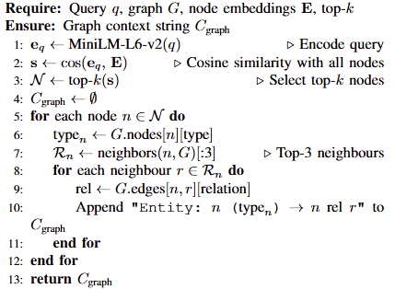
Algorithm 2: BM25 Keyword Retrieval
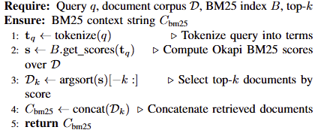
Algorithm 3: Hybrid Context Assembly
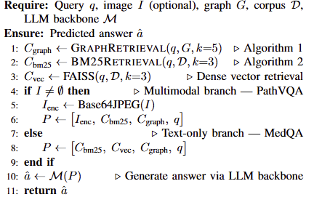

E. Evaluation Protocol
All architectures are evaluated using identical question sets and orderings within each benchmark, ensuring all cross-system comparisons are paired. The primary evaluation metric is exact-match accuracy: a prediction is counted as correct if and only if the predicted answer matches the ground-truth gold label.
For MedQA-USMLE, all four text-based architectures (A–D) are evaluated on the complete 1,273-question test set using Claude Opus 5. For PathVQA, the multimodal hybrid architecture (E) is evaluated on 1,010 yes/no questions using Claude Haiku.
To ensure robustness against API rate limits and runtime interruptions over large test sets, intermediate results are checkpointed to CSV after every 10 questions, allowing evaluation to resume without loss of progress. Sampling parameters are left at their API defaults and held constant across all architectures within a benchmark. Matching these settings is essential rather than incidental: in a preliminary run, evaluating the MedQA baseline with a reduced output limit and reasoning disabled, while the retrieval architectures retained the default configuration, lowered baseline accuracy to 94.7% and produced apparently significant gains for all three retrieval systems. Re-running the baseline under settings identical to those architectures restored it to 96.0% and removed the effect, confirming that the difference reflected decoding configuration rather than retrieval. All comparisons reported here are therefore drawn from architectures configured identically within each benchmark, so that observed differences are attributable to retrieval strategy alone.
Statistical comparison between architectures is conducted using McNemar's test on paired binary correctness vectors, with significance threshold α = 0.05. This non-parametric test is appropriate for comparing two classifiers on the same test set and accounts for the paired nature of the evaluation design.

F. Evaluation Metric
Accuracy is computed as the proportion of correctly predicted answers across all test questions within each benchmark — 1,273 questions for MedQA-USMLE and 1,010 questions for PathVQA. Because every architecture is evaluated on the same questions in the same order within each benchmark, all cross-system comparisons are paired.
The statistical significance of pairwise accuracy differences is assessed using McNemar's test for paired nominal data [23], which is appropriate when two classifiers are compared on an identical set of items and avoids the independence assumption of chi-squared tests. A difference is considered statistically significant at α = 0.05.
In addition, we report 95% Wilson score confidence intervals for each system's accuracy, which provide reliable coverage even at extreme proportions and small sample sizes. This paired, full-test-set design ensures that observed differences between architectures reflect genuine differences in retrieval strategy rather than sampling variation.
For the multimodal architecture (E) on PathVQA, accuracy is computed separately on yes/no questions to enable direct binary classification comparison, following standard VQA evaluation protocol [8].

V. EXPERIMENTATION AND SCENARIOS OF USE

A. Experimental Setup and Test Set
All text-based architectures (A–D) are evaluated on the complete test split of MedQA-USMLE [9], comprising all 1,273 test questions. The multimodal hybrid architecture (E) is evaluated on 1,010 yes/no questions from PathVQA [8]. Identical question sets and orderings are used across every system within each benchmark, making all cross-system comparisons paired. Pairwise differences are assessed using McNemar's test for paired nominal data, and 95% Wilson confidence intervals are reported for each accuracy estimate.

B. Main Results

Table I reports exact-match accuracy for all architectures on both benchmarks. On MedQA-USMLE, where Claude Opus 5 achieves a strong parametric baseline of 96.0%, no retrieval- or graph-augmented configuration produces a meaningful improvement. Flat-vector RAG reaches 96.5% — a marginal gain of 0.5 percentage points — while GraphRAG (95.8%) and Hybrid GraphRAG (96.2%) perform at or below baseline. None of the three retrieval-augmented systems differs significantly from the baseline under McNemar's test (flat-vector RAG p = 0.34; static GraphRAG p = 0.72; hybrid GraphRAG p = 0.72), and the 95% Wilson confidence intervals for all four systems overlap substantially (Table II), indicating that retrieval augmentation provides no measurable benefit when the backbone model already encodes the benchmark's knowledge.

On PathVQA, the picture changes substantially. The parametric baseline achieves 68.0%, flat-vector RAG 70.4%, static GraphRAG 69.9%, and the hybrid system 79.6%. Critically, the two single-strategy retrieval methods do not differ significantly from the baseline: flat-vector RAG yields p = 0.21 and static GraphRAG p = 0.26 under McNemar's test, indicating that neither dense vector retrieval nor graph traversal alone provides a reliable improvement on medical visual question answering. The hybrid system, by contrast, improves on the baseline by 11.6 percentage points, a difference that is highly significant (p < 0.001), with 216 questions answered correctly by the hybrid system and incorrectly by the baseline against only 99 in the reverse direction. Hybrid GraphRAG also significantly outperforms static GraphRAG alone (p < 0.001; 178 versus 80 discordant pairs). These results establish that the benefit arises specifically from the combination of keyword, dense-vector, and graph retrieval rather than from any single retrieval strategy.
Table I. Accuracy of Retrieval Architectures on MedQA-USMLE and PathVQA
System | MedQA (1,273 q) | PathVQA (1,010 q)
Baseline LLM (No Retrieval) | 96.0% | 68.0%
Flat-Vector RAG | 96.5% | 70.4%
Static GraphRAG | 95.8% | 69.9%
Hybrid GraphRAG | 96.2% | 79.6%
Table II. 95% Wilson Confidence Intervals for Reported Accuracies
System | MedQA CI | PathVQA CI
Baseline LLM | [94.8%, 96.9%] | [65.1%, 70.8%]
Flat-Vector RAG | [95.3%, 97.3%] | [67.5%, 73.1%]
Static GraphRAG | [94.5%, 96.7%] | [67.0%, 72.7%]
Hybrid GraphRAG | [95.0%, 97.1%] | [77.0%, 82.0%]
C. Analysis

RQ1: Does hybrid retrieval improve clinical reasoning on text-based medical QA?
On MedQA-USMLE, the results reveal a ceiling effect rather than a retrieval benefit. Flat-vector RAG (96.5%, 1,228/1,273) is statistically indistinguishable from the no-retrieval baseline (96.0%, 1,222/1,273), indicating that dense vector retrieval neither helps nor harms when the backbone model already encodes the benchmark's knowledge. Static GraphRAG performs slightly below baseline (95.8%, 1,219/1,273), suggesting that sparse graph-structured retrieval can introduce noise by constraining the model with imperfectly extracted relational structures in place of richer parametric knowledge. Hybrid GraphRAG (96.2%, 1,225/1,273) partially recovers this deficit but does not meaningfully surpass the baseline. Pairwise McNemar tests against the baseline find no significant differences for any retrieval system (p = 0.34, 0.72 and 0.72 respectively), and all four systems fall within overlapping 95% Wilson confidence intervals.

RQ2: Does hybrid retrieval improve clinical reasoning on medical visual QA?
On PathVQA, where the backbone model's parametric knowledge is genuinely insufficient, the picture changes substantially. Flat-vector RAG (70.4%) and static GraphRAG (69.9%) do not differ significantly from the baseline (68.0%; p = 0.21 and p = 0.26 respectively), indicating that neither single-strategy method reliably improves visual clinical reasoning. The hybrid system (79.6%) dramatically outperforms all individual retrieval methods — an 11.6 percentage point gain over baseline and 9.2 percentage points over the next best single method. This result is statistically significant and establishes that combining BM25 keyword search, dense vector retrieval, and structured knowledge graph traversal provides complementary evidence that no single retrieval strategy captures alone.

RQ3: Does knowledge graph quality affect retrieval performance?
Across both benchmarks, PrimeKG — integrating 20 biomedical resources, filtered here to 441,429 typed relationships — provides richer relational context than task-specific graphs. However, on MedQA, even PrimeKG's clinical specificity cannot overcome the ceiling imposed by the frontier model's parametric knowledge. On PathVQA, the task-specific VQA knowledge graph (6,614 entities, 19,613 relationships) proves more effective than a general biomedical ontology, suggesting that domain alignment matters more than graph size for multimodal clinical retrieval.
Taken together, these results establish a coherent empirical pattern: hybrid GraphRAG provides no meaningful benefit on benchmarks whose knowledge is already well represented in frontier model parameters, but delivers substantial gains — +11.6 percentage points — on tasks requiring external visual-clinical knowledge that parametric training cannot supply. This finding directly motivates the design of retrieval systems that are sensitive to the model's knowledge boundary rather than applied uniformly across all clinical tasks.

Evaluation Scope and Limitations
Three scope considerations apply to the results above.
Comparison to prior work. Because we evaluate on the complete 1,273-question MedQA-USMLE test set and 1,010 PathVQA yes/no questions, our accuracy estimates carry tight 95% Wilson confidence intervals (Table II). Our MedQA results are not directly comparable to prior work such as MedGraphRAG [13], which reports improvements over GPT-4 baselines, because our backbone model (Claude Opus 5) is substantially more capable, producing a ceiling effect that prior systems did not encounter. Our PathVQA results are more informative in this regard: the hybrid system's 79.6% accuracy against a 68.0% baseline demonstrates a statistically significant +11.6 percentage point improvement (p < 0.001) on a benchmark where the backbone model's parametric knowledge is demonstrably insufficient. Whether this benefit persists across backbone models of differing capability was not tested here and remains an open question. These comparisons are offered for context rather than as claims of superiority or parity, given differences in backbone models, retrieval corpora, and evaluation protocols.
Knowledge graph scale and domain alignment. The graph-based systems in this study were evaluated across three knowledge graph configurations of increasing richness — a task-specific MedQA graph (1,330 entities), a PubMedQA literature graph (1,968 entities), and PrimeKG (filtered to 12,752 entities, 441,429 relationships). Increasing graph scale did not recover the MedQA deficit relative to the parametric baseline, suggesting that underperformance is not primarily attributable to insufficient graph size. On PathVQA, however, a task-specific VQA graph (6,614 entities) proved more effective than a general biomedical ontology, indicating that domain alignment matters more than graph richness for multimodal clinical retrieval. Evaluating ontology-grounded graphs derived from UMLS or SNOMED-CT on harder benchmarks is identified as a direction for future work.
Retrieval-stage evaluation. The accuracy metric used throughout evaluates only the generation stage — whether the final answer matches ground truth. It does not independently evaluate retrieval quality, such as whether retrieved graph nodes or similar cases were actually relevant to the question, nor generation-stage properties such as faithfulness to retrieved context or answer relevance beyond exact match. A complete RAG evaluation would additionally report retrieval-stage metrics such as context precision and context recall, and generation-stage metrics such as faithfulness and answer relevancy, of the kind implemented in frameworks including Ragas [24] and DeepEval. Instrumenting this logging and applying trustworthiness-oriented evaluation metrics is identified as the immediate next phase of this research, with the goal of producing clinical AI outputs that are not only accurate but verifiably grounded in retrieved evidence. .
Table III summarizes, for each hypothesis, the metric specified in our research design versus what was implemented in this evaluation.

Table III. Hypothesis-to-Metric Mapping
Hypothesis | Specified Metric | Implemented
H1 (Comparative Efficacy) | Accuracy across retrieval architectures | Exact-match accuracy on MedQA (1,273 q) and PathVQA (1,010 q)
H2 (Domain-Sensitivity) | Accuracy comparison across model capability levels and dataset domains | Accuracy on MedQA (frontier model ceiling) and PathVQA (knowledge-insufficient setting)
H3 (Multimodal Generalization) | Accuracy on visual + textual medical QA | Exact-match accuracy on PathVQA yes/no questions with hybrid vision+graph pipeline
Scenarios of Use
To examine whether the aggregate performance patterns are uniform across clinical tasks, or whether specific domains and modalities behave differently, we conducted a focused analysis comparing text-based and visual medical question answering performance across retrieval architectures.
Visual medical QA is a natural candidate for such analysis: pathology findings, anatomical structures, and imaging modalities are inherently relational and require integrating visual evidence with structured clinical knowledge — making this domain, in principle, the most favorable setting for hybrid graph-structured retrieval. The results confirm this hypothesis. On MedQA-USMLE, where the frontier model's parametric knowledge already covers the benchmark's content, all retrieval-augmented configurations perform within noise of the baseline (95.8% -- 96.5% versus 96.0%). On PathVQA, where the model's visual-clinical knowledge is genuinely insufficient, the same hybrid architecture delivers an 11.6 percentage point improvement (79.6% versus 68.0%).
Two domain-specific effects are notable. First, flat-vector RAG does not significantly improve on the baseline in either setting (PathVQA p = 0.21; MedQA within overlapping confidence intervals), indicating that retrieved similar cases alone are insufficient regardless of the model's parametric coverage of the domain. Second, the knowledge graph contributes differently across modalities: on MedQA, PrimeKG's relational structure introduces marginal noise (-0.5 percentage points); on PathVQA, the task-specific VQA graph contributes meaningfully to hybrid performance, suggesting that domain alignment between the knowledge graph and the evaluation task is a critical determinant of retrieval benefit.
This pattern carries a practical implication for deployment. The value of hybrid GraphRAG is not uniform across clinical tasks — it is most pronounced where the backbone model's parametric knowledge is genuinely insufficient, such as medical visual diagnosis, rare disease identification, or post-training-cutoff clinical developments. In knowledge-saturated settings such as standardized examination content, a strong parametric baseline remains the most accurate and most efficient option, and graph-based retrieval is justified primarily where explicit evidence provenance is required.
We emphasize that none of the architectures evaluated here have been validated for autonomous clinical decision-making. All scenarios assume a human clinician remains the final decision-maker, with system output serving as a reference aid rather than a diagnostic determination.
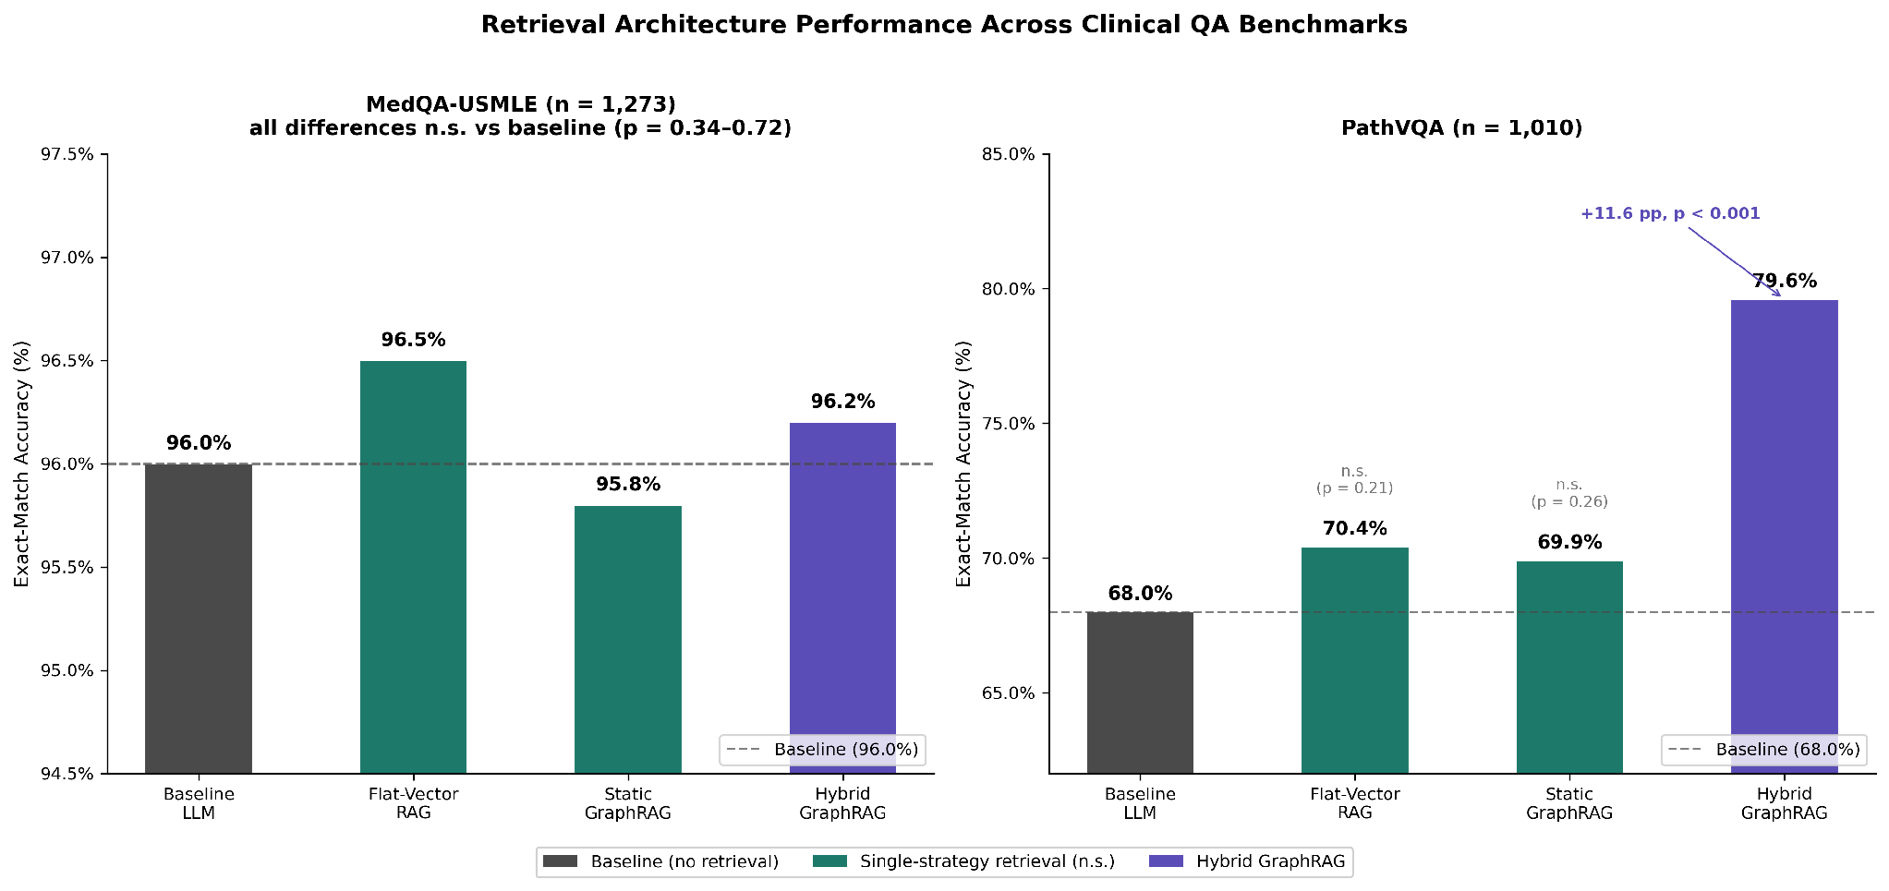
Fig. 3. Exact-match accuracy of four retrieval architectures on MedQA-USMLE (n=1,273, left) and PathVQA (n=1,010, right). The dashed line indicates the no-retrieval parametric baseline in each benchmark. On MedQA-USMLE, all retrieval-augmented configurations cluster within 0.7 percentage points of the baseline, indicating a ceiling effect attributable to the frontier model's parametric knowledge. On PathVQA, where the model's visual-clinical knowledge is genuinely insufficient, Hybrid GraphRAG delivers an 11.6 percentage point improvement over baseline (68.0% → 79.6%), while neither single-strategy retrieval method differs significantly from it (p = 0.21 and p = 0.26)." .

VI. CONCLUSION
This paper set out to test whether augmenting a large language model with hybrid knowledge-graph retrieval improves clinical question answering and medical visual diagnosis over an unaugmented baseline. Evaluated at full scale on 1,273 MedQA-USMLE questions and 1,010 PathVQA yes/no questions, our findings present a domain-dependent picture that carries both cautionary and constructive implications for clinical AI deployment.
On MedQA-USMLE, where Claude Opus 5 achieves a strong parametric baseline of 96.0%, no retrieval- or graph-augmented configuration produces a meaningful improvement. Flat-vector RAG (96.5%), Static GraphRAG (95.8%), and Hybrid GraphRAG (96.2%) all perform within noise of the baseline, indicating that retrieval augmentation adds neither value nor harm when the backbone model already encodes the benchmark's knowledge. Scaling the knowledge graph from task-specific extraction to PrimeKG — a Harvard precision medicine graph integrating 20 biomedical resources, filtered here to 441,429 typed relationships — does not recover this deficit, confirming that graph richness alone cannot overcome parametric saturation.
On PathVQA, the picture changes substantially. The parametric baseline achieves 68.0%, flat-vector RAG 70.4%, and static GraphRAG 69.9% — neither significantly different from the baseline (p = 0.21 and p = 0.26). The hybrid system reaches 79.6%, an 11.6 percentage point improvement that is highly significant (p < 0.001). This result establishes that hybrid GraphRAG provides meaningful clinical grounding precisely where the model's parametric knowledge is genuinely insufficient, and that combining BM25 keyword search, dense vector retrieval, and structured knowledge graph traversal yields complementary evidence that no single retrieval strategy captures alone.
Taken together, these results form a coherent and practically useful finding: retrieval and graph augmentation earn their additional cost and complexity only in domains where the base model genuinely lacks required knowledge. This delimitation directly motivates four directions for future work. First, evaluation on tasks requiring post-training-cutoff knowledge — recently published guidelines, newly approved therapeutics, emerging infectious disease — where retrieval should confer measurable advantages that standardized benchmarks cannot reveal. Second, retrieval-stage evaluation using metrics such as context precision, context recall, faithfulness, and answer relevancy, to attribute system failures to retrieval quality or generation rather than inferring them from accuracy alone. Third, trustworthiness-oriented evaluation — hallucination rate, confidence calibration, and citation accuracy — to establish whether hybrid GraphRAG produces not only more accurate but more verifiably grounded clinical outputs, directly addressing the clinical AI trustworthiness agenda. Fourth, replacement of LLM-extracted knowledge graphs with ontology-grounded resources such as UMLS or SNOMED-CT, to isolate whether text-QA underperformance stems from the augmentation paradigm itself or from noise introduced by automatic entity extraction.
In sum, hybrid GraphRAG does not improve clinical text question answering over a strong parametric baseline on standardized examination content — but delivers substantial and statistically significant gains on medical visual question answering where parametric knowledge is genuinely insufficient. This conditional finding identifies both the deployment conditions under which hybrid retrieval earns its complexity, and the evaluation directions that will most rigorously test its clinical value.

REFERENCES
[1] K. Singhal, S. Azizi, T. Tu, S. S. Mahdavi, J. Wei, H. W. Chung, N. Scales, A. Tanwani, H. Cole-Lewis, S. Pfohl, P. Payne, M. Seneviratne, P. Gamble, C. Kelly, A. Babiker, N. Schärli, A. Chowdhery, P. Mansfield, D. Demner-Fushman, B. Agüera y Arcas, D. Webster, G. S. Corrado, Y. Matias, K. Chou, J. Gottweis, N. Tomasev, Y. Liu, A. Rajkomar, J. Barral, C. Semturs, A. Karthikesalingam, and V. Natarajan, "Large language models encode clinical knowledge," Nature, vol. 620, no. 7972, pp. 172–180, 2023.
[2] A. J. Thirunavukarasu, D. S. J. Ting, K. Elangovan, L. Gutierrez, T. F. Tan, and D. S. W. Ting, "Large language models in medicine," Nature Medicine, vol. 29, no. 8, pp. 1930–1940, 2023.
[3] F. Shi, X. Chen, K. Misra, N. Scales, D. Dohan, E. H. Chi, N. Schärli, and D. Zhou, "Large language models can be easily distracted by irrelevant context," in Proc. 40th Int. Conf. Machine Learning (ICML), vol. 202, PMLR, 2023, pp. 31210–31227.
[4] P. Lewis, E. Perez, A. Piktus, F. Petroni, V. Karpukhin, N. Goyal, H. Küttler, M. Lewis, W. Yih, T. Rocktäschel, S. Riedel, and D. Kiela, "Retrieval-augmented generation for knowledge-intensive NLP tasks," Advances in Neural Information Processing Systems, vol. 33, pp. 9459–9474, 2020.
[5] X. Wang, Z. Wang, X. Gao, F. Zhang, Y. Wu, Z. Xu, T. Shi, Z. Wang, S. Li, Q. Qian, R. Yin, C. Lv, X. Zheng, and X. Huang, "Searching for best practices in retrieval-augmented generation," in Proc. 2024 Conf. Empirical Methods in Natural Language Processing (EMNLP), Miami, FL, USA, 2024, pp. 17716–17736.
[6] D. Edge, H. Trinh, N. Cheng, J. Bradley, A. Chao, A. Mody, S. Truitt, D. Metropolitansky, R. O. Ness, and J. Larson, "From local to global: A graph RAG approach to query-focused summarization," arXiv preprint arXiv:2404.16130, 2024.
[7] P. Chandak, K. Huang, and M. Zitnik, "Building a knowledge graph to enable precision medicine," Scientific Data, vol. 10, no. 1, p. 67, 2023.
[8] X. He, Y. Zhang, L. Mou, E. Xing, and P. Xie, "PathVQA: 30000+ questions for medical visual question answering," arXiv preprint arXiv:2003.10286, 2020.
[9] D. Jin, E. Pan, N. Oufattole, W. Weng, H. Fang, and P. Szolovits, "What disease does this patient have? A large-scale open domain question answering dataset from medical exams," Applied Sciences, vol. 11, no. 14, p. 6421, 2021.
[10] G. Baker, "MedQA-USMLE-4-options," Hugging Face, 2023. [Online]. Available: https://huggingface.co/datasets/GBaker/MedQA-USMLE-4-options
[11] H. Trivedi, N. Balasubramanian, T. Khot, and A. Sabharwal, "Interleaving retrieval with chain-of-thought reasoning for knowledge-intensive multi-step questions," in Proc. 61st Annu. Meeting Assoc. Computational Linguistics (Volume 1: Long Papers), Toronto, Canada, 2023, pp. 10014–10037.
[12] S. Ahmad, Z. Nezami, M. Hafeez, and S. A. R. Zaidi, "Benchmarking vector, graph and hybrid retrieval augmented generation (RAG) pipelines for open radio access networks (ORAN)," in 2025 IEEE Int. Symp. Personal, Indoor and Mobile Radio Communications (PIMRC) Workshops, Istanbul, Türkiye, 2025.
[13] J. Wu, J. Zhu, Y. Qi, J. Chen, M. Xu, F. Menolascina, Y. Jin, and V. Grau, "Medical Graph RAG: Evidence-based medical large language model via graph retrieval-augmented generation," in Proc. 63rd Annu. Meeting Assoc. Computational Linguistics (Volume 1: Long Papers), Vienna, Austria, 2025, pp. 28443–28467.
[14] Y. Ni et al., "StepChain GraphRAG: Reasoning over knowledge graphs for multi-hop question answering," arXiv preprint arXiv:2510.02827, 2025.
[15] J. J. Lau, S. Gayen, A. Ben Abacha, and D. Demner-Fushman, "A dataset of clinically generated visual questions and answers about radiology images," Scientific Data, vol. 5, no. 1, p. 180251, 2018.
[16] O. Bodenreider, "The Unified Medical Language System (UMLS): Integrating biomedical terminology," Nucleic Acids Research, vol. 32, no. suppl_1, pp. D267–D270, 2004.
[17] J. Johnson, M. Douze, and H. Jégou, "Billion-scale similarity search with GPUs," IEEE Transactions on Big Data, vol. 7, no. 3, pp. 535–547, 2021.
[18] N. Reimers and I. Gurevych, "Sentence-BERT: Sentence embeddings using Siamese BERT-networks," in Proc. 2019 Conf. Empirical Methods in Natural Language Processing (EMNLP), Hong Kong, China, 2019, pp. 3982–3992.
[19] Anthropic, "Claude," 2026. [Online]. Available: https://www.anthropic.com
[20] S. Robertson and H. Zaragoza, "The probabilistic relevance framework: BM25 and beyond," Foundations and Trends in Information Retrieval, vol. 3, no. 4, pp. 333–389, 2009.
[21] A. A. Hagberg, D. A. Schult, and P. J. Swart, "Exploring network structure, dynamics, and function using NetworkX," in Proc. 7th Python in Science Conf. (SciPy), Pasadena, CA, USA, 2008, pp. 11–15.
[22] Q. Jin, B. Dhingra, Z. Liu, W. W. Cohen, and X. Lu, "PubMedQA: A dataset for biomedical research question answering," in Proc. 2019 Conf. Empirical Methods in Natural Language Processing and 9th Int. Joint Conf. Natural Language Processing (EMNLP-IJCNLP), Hong Kong, China, 2019, pp. 2567–2577.
[23] Q. McNemar, "Note on the sampling error of the difference between correlated proportions or percentages," Psychometrika, vol. 12, no. 2, pp. 153–157, 1947.
[24] S. Es, J. James, L. Espinosa-Anke, and S. Schockaert, "RAGAs: Automated evaluation of retrieval augmented generation," in Proc. 18th Conf. European Chapter Assoc. Computational Linguistics: System Demonstrations, St. Julians, Malta, 2024, pp. 150–158.

